1. **Digital Signature Workflow**

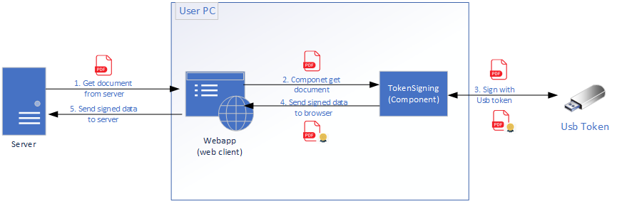

TokenSigning is the component which you need!

Steps:

* 1. Webapp (browser) get document from server (in example bellow ignore this step and the document is fixed in code)
* 2. TokenSigning get the document from browser
* 3. TokenSigning sign the document by Usb token
* 4. TokenSigning send signed document to browser
* 5. Browser send signed document to Server

1. **You requirements**

- Data Signing: xml, pdf, office, text

=> OK  
- Support usb token, smartcard, keyfile

=> OK

- The signature hash must be SHA-256

=> OK  
- Reading user cerificate information in pc

=> OK

- Extract information from certificate

=> OK (Serial number, name, valid date, issuser,…)  
- Browser support: Google Chrome, Firefox, Edge, Safari, Opera.

=> OK  
- Operation support: Windows, MacOS, Linux

=> OK

+ TokenSigning Installer for Windows: DONE

+ TokenSigning Installer for MacOS: Building

+ TokenSigning Installer for Linux: Building

- The component checks against a certificate revocation list (CRL).

=> not yet. I will add soon!

- Timestamp

=> OK (see in Example)

- Show the document in the signing process, by selecting the certificate to sign, see the document that I am going to sign.

=> OK (see in Example)

- When signing, we need to add a mark to the document a text with a picture + the name of the signer.

=> OK (See example)

=> You can view file pdf

=> add signatures, image to signature, text, color, location, page…

=> add comment to file pdf, comment location, page, text,…

1. **Example (webclient)**

- How to use

1. Install installer TOKEN SIGNING_Setup_1.0.0.2.exe in your computer

2. Open file webclient\signPdf-Advanced.html by your browser

3. Before Document Signing, you can set timestamp and other signature option

You can set timestamp url like bellow

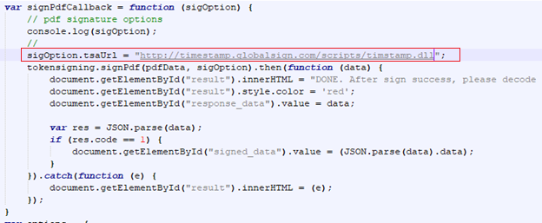

More signature options, you can see object PdfSignatureOption in tokensigning.js

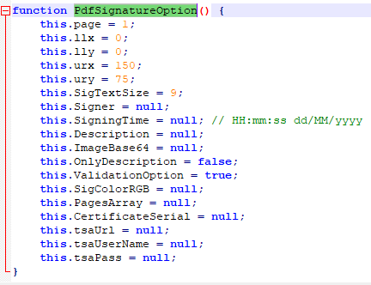

3. Click SignPdf() to sign pdf document

The document I have fixed (pdfData variable)

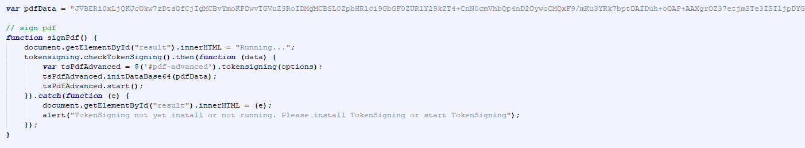

4. Pdf advanced module

You can preview file, add signatures, comments, …

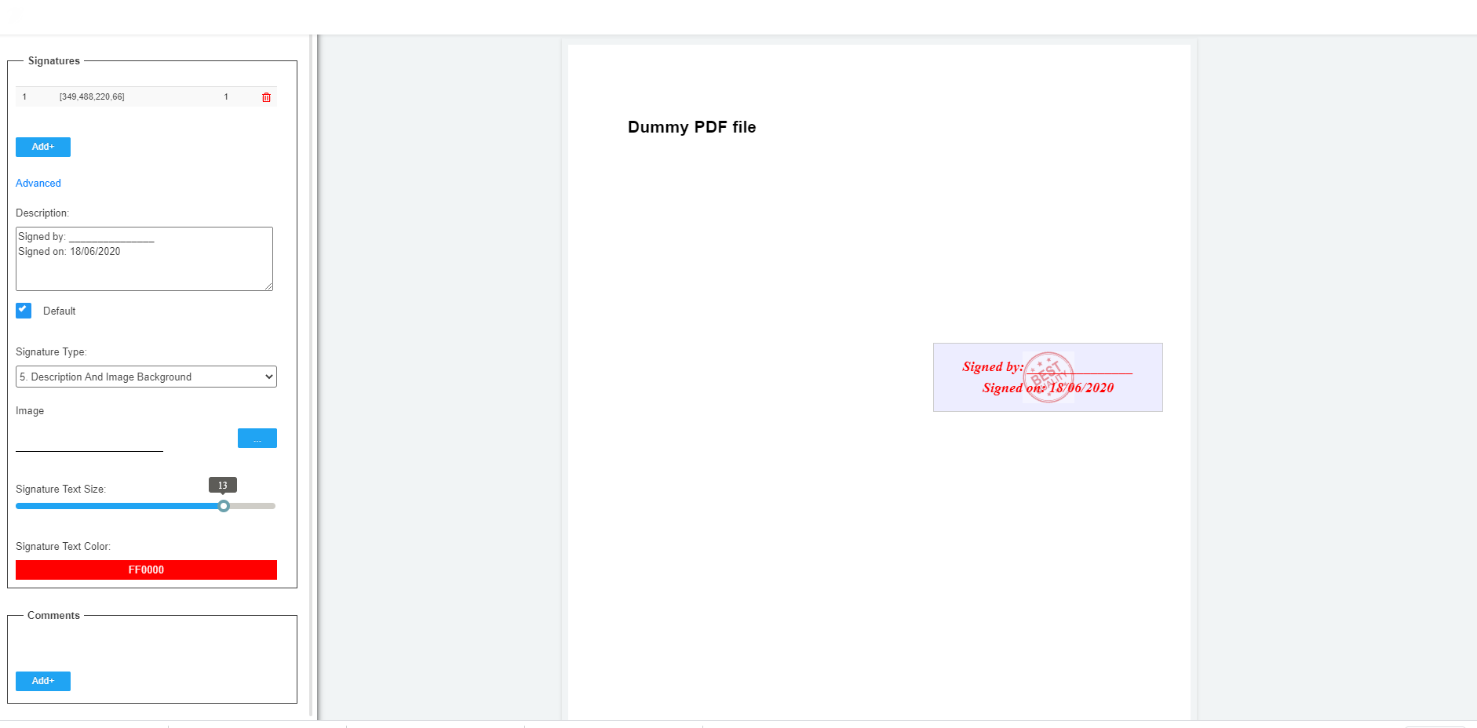

6. Signed document

